DEPTH OF FIELD & FOCAL LENGTH
Why is it that in some photographs, objects both close to and far from the lens are both in relatively clear focus, while in other photos, only things in the foreground or the background are in focus, but not both? What is this effect and how does a photographer manipulate this?
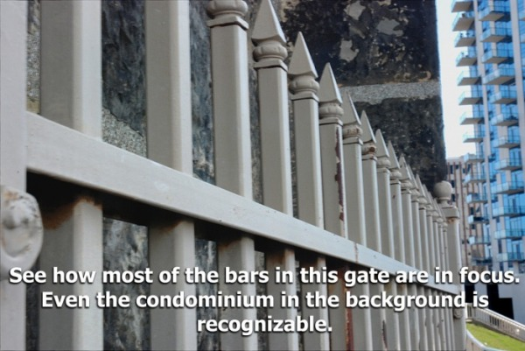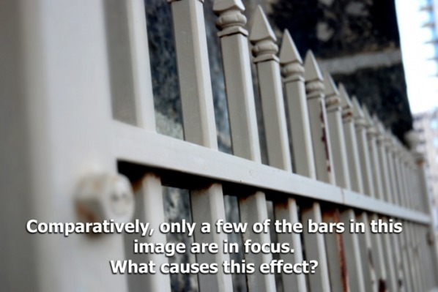
D E P T H O F F I E L D
Looking at the two images above, it's clear to see that in one of them, not all is clear! O.K., let's put aside the puns and get a better sense of what is going on here.
The effect has something to do with "Depth of Field".
Some people refer to this as depth of focus, but the proper term is, again, depth of field.
Here's a definition you that's fairly easy to understand.

Depth of Field refers to the chunk of space between the lens and infinity in an image that is acceptably clear.

SHORT Depth of Field refers to a narrow field of view that is in focus. When objects in the foreground, mid-ground, or background are exclusively in focus, this is referred to as short depth of field.

LONG Depth of Field, by contrast, refers to a wide field of view that is in focus. With long depth of field, objects are in focus both the foreground and mid-ground, or in the mid-ground as well as background, or even from the foreground all the way through to the background.

DEPTH OF FIELD & FOCAL LENGTH
Identification & Explanation
Identify whether the image’s focal length represents a short depth of field or long depth of field AND explain your answer.

1.

2.

3.

4.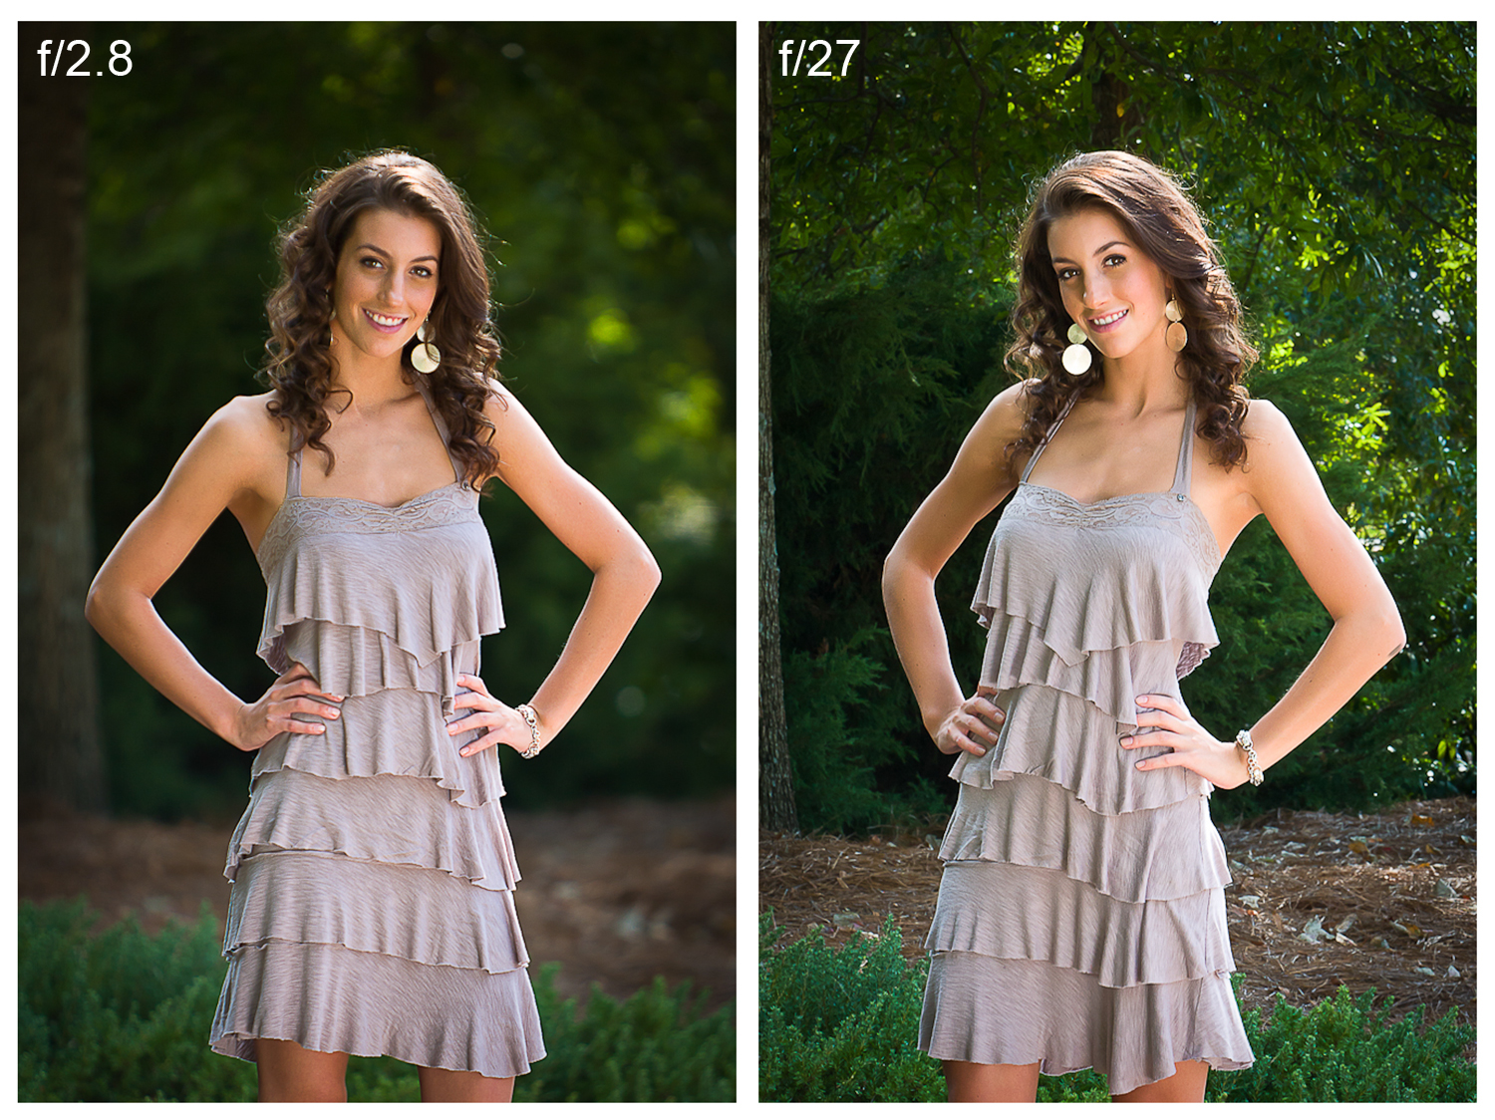

5.

6.

FOCAL LENGTH EXAMPLE
